AHC Quarterly Board Meeting Minutes

Title | AHC Annual Board Meeting
Date | Tuesday, June 19, 2018
Time | 4:30pm to 5:30pm ET
Location | Conference Bridge

ROLL CALL
BOARD MEMBER | PRESENT?
Christy Morris – President | Y
Chris Geldart – Vice President | Y

Vacant – Secretary
Mike Ambrosio - Treasurer | Y
Jim Sheehan | Y
Ira Tannenbaum | Y
Kelly McKinney | N
Joe Picciano | Y
Tom O’Reilly | Y
Joe Bruno | N
Bud Mertz | Y
Chris Eisenbrey | Y

PMO
Tom Moran | Y
John Molnar | N
Tom Hyatt | Y

Invited Guests

ACTION ITEMS or DECISIONS MADE or RECOMMENDATIONS
Item | Responsibility | Due
AHC Board website:
http://www.ahcusa.org/ahc-board.html

- Voted to approve new slate of Board Officers

MINUTES -

Discussion Items:

Governance:

Determination of a quorum….a quorum was achieved
Minutes from Feb 2018 meeting were approved (Motion: Ambrosio 1st, Mertz 2nd, all agreed)

NOTES:

The meeting was called to order by Board President Christy Morris.

A quorum was reached.

Review of the minutes took place. A motion to approve the minutes was provided by Mike Ambrosio, a second motion to approve was provided by Bud Mertz. Minutes from the February 2018 board meeting were approved.

Finance Report
Tom Moran provided a briefing on the finances for the Consortium. AHC has hired a new accounting/bookkeeping person who is working w/John Molar to update our processes and streamline reporting. The finance report was not provided to the Board during the meeting but will be provided once completed.

The balance on the note to Integrity Consulting has been paid down to approximately $75,000 and we hope to pay this off completely in 2018 if things go as planned.

AHC is also in discussions with a bank to Establish a line of credit so we don’t tie up the AHC’s working capital on staffing positions with DC government and other related projects in the future.

No questions were offered by the Board.

Board Election/Vote for New Officers

Christy Morris introduced the new slate of officers for the Board. The slate had been circulated prior to the meeting. Discussions were proposed but none were required.

Chris Geldart - President
Mike Ambrosio – Vice President
Kelly McKinney - Treasurer
Chris Eisenbrey - Secretary

A vote was taken, all approved, none disapproved.

New officers will assume their roles when this meeting concludes.

Legal update

Tom Hyatt, the Consortium legal counsel, provided a legal update with regards:

- New AHC ventures being discussed w/Tom Moran that could expand the AHC service. In the case where revenues derived from these new ventures and how we can be consistent with the AHC 501c3 model and if things grow, the AHC can opt to establish a spin off subsidiary organization of our own or via partnerships… nothing to decide for now
- The AHC addressed some housekeeping issues with State Annual Reporting which has all been cleaned up.

Board Updates:

Operational (Moran)

Feb 2018 Board Meeting Board Committee Report Outs

Action Items from the February Annual Board Meeting were delayed. Several have moved forward but nothing formal was organized. Moran will follow up on this and organize the project management plan to track the progress as agreed to. See list of actions below.
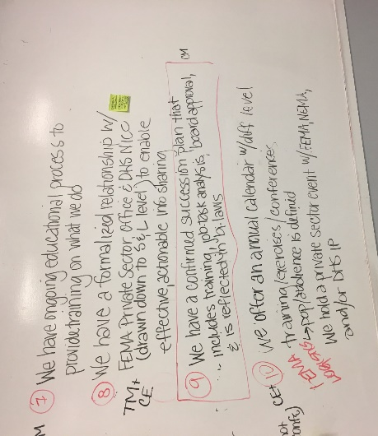
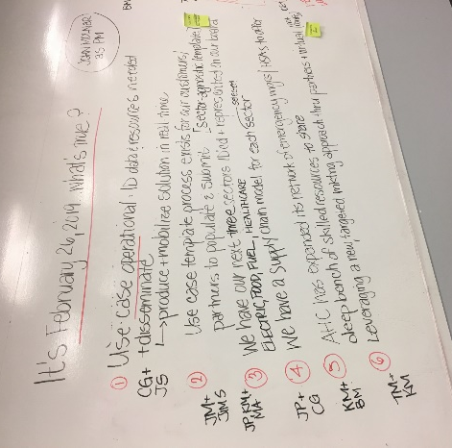

b) US DOT Federal Motor Carrier Safety Administration Relationship

Chris Eisenbrey provided brief on AHC meeting with US/DUT Federal Motor Carrier Safety Administration, they oversee the state weigh station and enforcement of the IFTA and IRP Tax laws. AHC met with Director and Deputy Director and entire sr. staff to discuss expediting FMCSA waivers and declarations in support of fleet movement for power and supply chain restoration. More meetings to come along with education and product development.

Current Initiatives

Long-term draft BUDGET estimate for AHC/SISE Framework (McKinney/Geldart)

Chris Geldart provided board members with a brief on the status of developing a long-term budget and strategy for the sustainment of the consortium and its sensitive information sharing environment or SISE.

Geldart, Moran, McKinney, Eisenbrey and several other board members and advisors have been working with working groups to develop this budget of the last 18 months. The budget outlines the cost to provide staff, Offices, technology, legal, and other support required for developing sector focus working groups in order to replicate processes in other sectors as has proven successful within the multi-state late response working group for the electric sector.

A draft budget has been prepared and will be provided to the board for review and discussion later.

Geldart mentioned that the AHC is now receiving funding from federal agencies which can bring along with it other non-operational missions. Chris mentioned that it was important for Consortium to remember what made it valuable to the private sector and state was its ability to produce results and operational solutions and not just meetings and reports.

As we move forward and work with the different offices within federal agencies and private sector partners and state and local partners, we must remember as an organization to remember what makes us the most effective is to remain focused on solving problems.

b) Pennsylvania Private Sector Integration Project

Tom Moran commented the same is true at the state level, and Pennsylvania for example the Consortium is working with the Pennsylvania emergency management agency and several counties to help build a private sector integration model in the Commonwealth of Pennsylvania.
Bud Mertz is part of this effort in Pennsylvania. Bud briefed the Board on the desire to create a network of businesses that can plan with state and local government emergency managers to begin addressing recovery issues sooner, this helps everyone get things back to normal faster and restore power, food stores, water, fuel supply lines, and local businesses faster following any type of disaster.

But stated many times Government can make critical decisions that impact the private sector without the private sector being present or even knowing about the decisions. This is not helpful for government or private sector. The current private sector in a Gratian effort in Pennsylvania will allow those people to be part of a framework that will have those discussions before the disasters occur so that once disaster strikes, these policies and processes will be in place which will help coordination during response efforts Improve dramatically.

c) Healthcare Sector Resilience RRAP (Regional Resilience Assessment Program)

Joe Picciano briefed the Board on the Health Sector Supply Chain Resilience Regional Resiliency Assessment Program project conducted with DHS over the past 18 months.
DHS has asked Joe for another proposal to look at other related topics within healthcare supply chain resilience. Joe will include Consortium and the Priority 5 solution as part of this next proposal that will tie in the SISE framework to support healthcare sector’s sensitive information sharing needs going forward.

The SISE concept continues to play in important role in the private sector/public sector information sharing going forward across multiple sectors. We want to continue leveraging this capability in the healthcare sector.

d) Ira Tanenbaum Update

Ira provided the Board with an update on his health situation that resulted from a rare allergic reaction to a medication called Stevens-Johnson Syndrome. He is recovering, back to work and getting stronger every day. He appreciates everyone’s thoughts and prayers and warm wishes and looking forward to more involvement.

e) DHS R&D Initiative with AHC/Private Sector

Tom Moran provided the Board with a brief on a new development.

DHS approached the Consortium about facilitating research and development efforts that leverage private sector entities.

Due to the success of our past efforts under the DHS NIPP Challenge Program, along with trends in federal government to streamline traditional research and development efforts.
The Consortium has been selected for consideration as part of a new effort to privatize some parts of research and development across federal agencies.
The Consortium officers will be engaged in the dialogue with DHS to discuss the Consortium‘s role in the process and to move this discussion forward …. which could result in some rather large research and development projects in the near future.

f) Christy Morris Remarks
Christie thanked the Board for their service and expressed her pleasure in providing a leadership role as president since July 2013.
In her normal fun kind-of-way, she once again reminded the Board about a few things:

- Succession planning for Tom Moran, and officers going forward
- She expressed her appreciation for the video updates being produced by the program office to keep the board and working group leader ship informed
- Christy expressed her thoughts about the Consortium starting with big dreams and little budget, not being sure where we wanted to go, and trying to be all things to all people. Now the AHC has really found its niche in the public/private information sharing arena and she encouraged the Board to be very thoughtful in their future considerations as they shape the future policies and initiatives where ever the Consortium will go.
- To find more women to be on the Board of Directors
- And to pay off the loan to Integrity consulting and become debt-free as an organization

She thanked the Board for their faith in her for the past 5 1/2 years and she urged the Board to remember to have fun, play hard, work hard and have

Conclusion
After final comments by Chris Geldart the meeting was adjourned.

2018 Full Board Meeting Conference Call Schedule

- September 18, 2018, 4:30-5:30 PM ET
- December 18, 2018, 4:30-5:30 PM ET

Supporting Documents
- Agenda
- Feb 2018 Meeting Minutes
- AHC Finance Report
- AHC Board Member Matrix Directory

Parking Lot:
- 2018 Board Governance – New Slate of Officers
- AHC Overhead rate increase to 10%
- 2019 Board Annual Meeting – Date/Location
- Update DRAFT 2018 Strategic Plan
- Board Committee formation
- Update AHC Board of Director Manual

