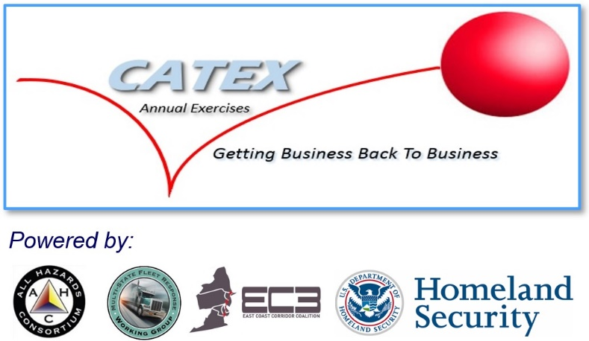

CATEX 2016

Drill
  - Read-Ahead (Revised June 30, 2016)

This Exercise Read-Ahead provides participating agencies and organizations with information needed to register and participate in the Catastrophic Exercise Series (CATEX) 2016 scheduled for August 10, 2016 from 9:30 a.m. to 3:00 p.m.
The contents include:
- Overview of CATEX 2016 email based functional exercise.
- Preliminary exercise schedule.
- References to tools and guidelines that will be utilized during exercise conduct.
Invitees are requested to follow enclosed instructions to:
- Register for the exercise.
- Register for access to the SISE (Sensitive Information Sharing Environment) Tool, operated by the All Hazards Consortium and its partners.

Note: Information provided in this Read-Ahead is subject to change with exception to the exercise date and time to conduct. Registered participants will receive an Exercise Plan (ExPlan) once information is finalized prior to the exercise being conducted.

Exercise Overview
Exercise Name | CATEX 2016
Exercise Date and Time | August 10, 2016 from 0930 – 1500.
Scope | The All Hazards Consortium’s multi-state Fleet Response Working Group (AHC/FRWG) will conduct a four (4)-hour functional exercise that will focus on awareness and application of FRWG Disaster Response Tools and Processes in support of regional electric power restoration efforts across the Eastern United States and Canada. This exercise will be operational, not discussion-based. Participants will attend the exercise virtually. Information sharing will be limited to email exchange and web-based collaboration tools. No assets or resources will be deployed.
Objectives | - Evaluate participant’s functional knowledge of AHC FRWG processes and tools.  - Stress test some key elements of the FRWG’s Regional Fleet Movement Coordination Initiative process and Sensitive Information Sharing Environment (SISE) information sharing tools to determine gaps.  - Confirm roles and responsibilities across the following entities:  - Regional Mutual Assistance Groups (RMAGs) – in electric sector  - State and Local Government Agencies  - Federal and Canadian Government Agencies  - Trade Associations  - Participating Sectors (Food/Water, Fuel, Telecom, Finance, Retail and Transportation)  - The Fleet Response Working Group (FRWG) Program Office  - Discuss logistical challenges when initially aligning resource needs between utilities.  - Assess overall communications, operational process efficiency and tool(s) operational effectiveness.  - Identify strengths, areas for improvement and assign corrective actions.  - Education on the FRWG’s Fleet Movement Coordination with State’s process and tools.
Threat or Hazard | Natural hazard, severe weather similar to a “Derecho” event.
Scenario | Predicted but isolated severe weather in the mid-west turns into a regional, widespread severe storm with little to no advance notice. The storm is projected to pass over States in the Mid-Atlantic and Northeast regions during a period of excessive heat, high temperatures, and high electrical load periods.
Sponsors | - All Hazards Consortium’s Multi-State Fleet Response (FRWG) Working Group and the East Coast Corridor Coalition (EC3) Working Group  - U.S. Department of Homeland Security Office of Infrastructure Protection (DHS / IP)  - Regional Mutual Assistance Groups (RMAG) in Electric Sector:  - Southeastern Electric Exchange, Great Lakes, North Atlantic, Mid-West  - Investor Owned Utilities (IOU)  - U.S. Department of Energy (DOE)  - U.S. Department of Transportation (DOT)  - Federal Emergency Management Agency (FEMA)  - U.S. Customs and Border Protection (CBP)  - Edison Electric Institute (EEI)  - National Rural Electric Cooperative Association (NRECA)  - American Public Power Association (APPA)
Point of Contact | Tom Moran  Executive Director  All Hazards Consortium  Cell: 443-718-9109  catex2016@ahcusa.org

Exercise Schedule
August 10, 2016
Time |  | Activity
0930 – 1000 | Registration and Plenary Session
1000 – 1145 | Exercise Conduct: Phase I and II
1145 – 1245 | Lunch
1245 – 1430 | Exercise Conduct: Phase III and IV
1430 – 1450 | Hot Wash
1450 – 1500 | Next Steps & Closing Comments

Exercise “Player” Registration Processes

Complete Exercise Attendance Registration Process:
Please register to participate in the exercise by August 8, 2016 at the following link: http://events.constantcontact.com/register/event?llr=zbu8kubab&oeidk=a07ecveqe520d43370c

Complete SISE (Sensitive Information Sharing Environment) Registration Process:
Please pre-register to access SISE tools by August 8, 2016 using the following process:
- Link to SISE Portal Webpage at http://ahcportal.skylinecsg.com/site/login
  - First Time SISE Users
    - CLICK on above link to create your personal SISE account
    - Fill in the information on webform
      - Choose a sponsor from the “pull down menu”
    - You should get an email within 24 hours once you are approved by your sponsor (check your SPAM filters too)
    - Once approved, return to SISE Portal and login in using your email, password and cell phone
      - You will get a cell phone text message each time you login in order for SISE portal to validate your identity
  - For Already Registered SISE Users
    - Simply go to SISE Portal webpage login in using you email, password and cell #

References

AHC / FRWG Technology and Services To Be Tested
URL: http://www.ahcusa.org/catex-2016-tools-tested.html

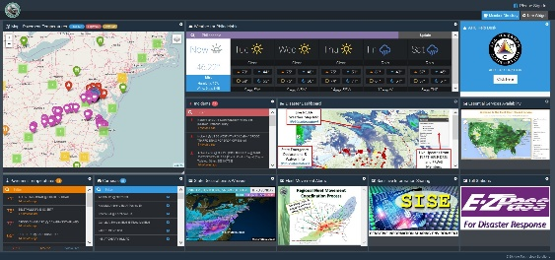
- SISE (Sensitive Information Sharing Environment) Portal
- SISE Enrollment: http://ahcportal.skylinecsg.com/site/login
- SISE Portal Access: http://ahcportal.skylinecsg.com:90/

- GeoCollaborate Technology
- Regional GeoCollaboration Tool Access: https://frwg.geocollaborate.com/
- GeoCollaborate Daily Dashboard: https://frwg.geocollaborate.com/offline/
- Services
- Fleet Open/Closed for Locating Essential Services During Disasters: www.fleetopenclosed.org
- Storm Central for centralized emergency declarations: http://www.ahcusa.org/storm-central.html

Processes and Guidance To Be Tested
- AHC / FRWG Disaster Response Tools Website:
  - Link: http://www.fleetresponse.org/resources/hurricane-season/

- Regional Fleet Movement Coordination Initiative Overview Process (PDF)
- Link: http://www.fleetresponse.org/wp-content/uploads/sites/2/2014/07/Fleet_Movement_Coordination_Inititiative_Info_packet_7_3_2014.pdf

- RMAG Coordination Guide for the Regional Fleet Movement Coordination Process (PDF)
- Link: http://www.fleetresponse.org/wp-content/uploads/sites/2/2015/06/06-1-15-RMAG-FRWG-Engagement-Guidance-Final-tm.pdf

- US / Canadian Border Crossing Process (PDF)
- Link: http://www.fleetresponse.org/wp-content/uploads/sites/2/2014/07/07-03-13-USCANADA-BorderGuidance-Only.pdf

Educational Websites & Information

- All Hazards Consortium Website
- Link: www.ahcusa.org

- Multi-State Fleet Response Working Group Website
- Main webpage link: www.fleetresponse.org
- Disaster Response Tools - http://www.fleetresponse.org/resources/hurricane-season/
- SISE Working Group Website: www.fleetcyberid.org
- The CATEX 2016 Annual Exercise Series link: http://www.fleetresponse.org/productsservices/annual-exercise/catex-2016/

CATEX 2016 Educational Video & Training Website

- CATEX 2016 Education Website
- Link: http://www.ahcusa.org/catex-2016-education.html

